
COMSATS University, Islamabad Pakistan

SkyRecon

By

Safaan Umar CIIT/FA22-BAI-028/ISB
Ibrahim Arshad CIIT/FA22-BAI-015/ISB

Supervisor
Ms. Anum Zahra

Bachelor of Science in Artificial Intelligence (2022-2026)

The candidate confirms that the work submitted is their own and appropriate
credit has been given where reference has been made to the work of others.

COMSATS University, Islamabad Pakistan

SkyRecon

A project presented to
COMSATS University, Islamabad

In partial fulfillment
of the requirement for the degree of

Bachelors of Science in Artificial Intelligence
(2022-2026)

By

Safaan Umar CIIT/FA22-BAI-028/ISB
Ibrahim Arshad CIIT/FA22-BAI-015/ISB

Declaration

We hereby declare that this software, neither whole nor as a part, has been copied out from any source. It is further declared that we have developed this software and the accompanying report entirely on the basis of our personal efforts. If any part of this project is proved to be copied or found to be a reproduction of another, we accept full responsibility for the consequences. No portion of this work has been submitted elsewhere for any other degree or qualification.

Safaan Umar Ibrahim Arshad

Certificate of Approval

It is to certify that the final year project of BS (CS) Dukan was developed by
SAFAAN UMAR (CIIT/FA22-BAI-028) and IBRAHIM ARSHAD (CIIT/FA22-BAI-015) under the supervision of MS. ANUM ZAHRA and in her opinion; it is fully adequate, in scope and quality for the degree of Bachelors of Science in Artificial Intelligence.

---------------------------------------
Supervisor

---------------------------------------
External Examiner

---------------------------------------
Head of Department
(Department of Computer Science)

Executive Summary
SkyRecon is a state-of-the-art drone platform driven by artificial intelligence that raises the aviation safety bar sky high. It can now independently detect and analyze foreign object debris (FOD) present on airport flight paths. The debris may attract birds lint and lead to catastrophic consequences like a flight delaying discrepancy, equipment damage, and possible safety concerns. Traditional manual inspection methods are
slow and resource-consuming as well as variable. SkyRecon attaches the temporal and spatial issues related to waste disposal through a combination of computer vision, reinforcement learning, and communication technologies in the cloud which provide a scalable, real-time, automated solution.
The structure of the suggested system is based on two modes — simulation and hardware. In the former case, simulated drones are used within an environment like AirSim to ensure safe training and evaluation of the AI models. Because of this, the agents of reinforcement learning can create the highest possible navigational and coverage policies using algorithms like Proximal Policy Optimization (PPO) and Deep Deterministic Policy Gradient (DDPG). In the hardware mode, real drones establish a secure communication protocol like MQTT or WebSocket that connects to a cloud inference backend. The drones capture live video and stream it to the cloud, which performs the AI-based debris detection using YOLOv8, a state-of-the-art object detection model.
Once the debris is detected, skyRecons Geospatial Mapping Module presents the results with a dynamic map interface. Each detection event is tagged with geographical coordinates, confidence levels are annotated, and material types are classified. Hazard Analysis Module is the one to determine the level of severity by means of debris and the distance to critical flight areas. All of this information is consolidated into a centralized web dashboard used as the main control panel for the airport. The dashboard features live telemetry of the drone, detection overlays, hazarding analytics, and alert notifications which rather easy the transmission of response actions.
The structure of SkyRecon is modular, cloud-based architecture allowing effortless scalability, fault tolerance, and integration of existing airport programs. It also considers regulations on safety issues like geofencing, altitude limits, and emergency handling to comply with UAV operational guidelines. The dual nature of the system, it is both a research-oriented simulation and a piece of hardware to be deployed, it links the gap between academic innovations and real-world aviation applications.
SkyRecon is on the forefront of the implementation of AI-backed ways of measuring dangers in flight paths, providing real-time feedback through visualization, and a change in the airport’s approach to the security of operations, all at the same time. The project is not merely a demonstration of the benefits derived from the integration of artificial intelligence, robotics, and the cloud but also a means of assuring people that the investments made would definitely yield returns in later projects.

Abstract

SkyRecon's main purpose is to pioneer the way to more safety in aviation by leveraging the power of technological solutions like artificial intelligence and drone to detect debris on airport runways and flight paths automatedly. The prevailing systems are heavily dependent on manual inspection, and besides that, they have stationary surveillance cameras which have a limited field of view, and they react slowly. The human factor is also one of the major contributors to the errors. The current debris management practices lack the ability to provide real-time data analytics and independent vehicle integration for the method of hazard detection being difficult. SkyRecon approaches these problems by the means of a smart, cloud-based drone infrastructure that could work autonomously, offer immediate debris categorization, and create hazard visualization. The project is dedicated to providing a scalable, fully-autonomous runway monitoring system that can change from virtual to actual hardware environments easily. The pivotal missions are to create an AI vision model for YOLOv8-based debris detection, to make optimal path planning of drone flights using reinforcement learning algorithms, and to secure cloud communication framework with live data for streaming and analysis. Furthermore, the project intends to generate geospatial heatmaps and provide airport authorities with actionable hazard insights through a web dashboard. In the end, the value of the project will be in the enhancement of the airport's operational safety, the reduction of the manual activity, and elimination of bird strikes by a reliable, intelligent, and entirely autonomous aerial monitoring system.

Acknowledgment

We are deeply grateful to Allah Almighty for granting us the strength, wisdom, and perseverance to complete this project. We would like to express sincere gratitude to our supervisor, Ms. Anum Zahra, for her continuous support, insightful feedback, and invaluable guidance throughout our research and development process. We are also thankful to our families and friends for their patience, motivation, and encouragement.

Safaan Umar Ibrahim Arshad

List of Abbreviations

Abbreviation | Description
AI | Artificial Intelligence
UAV | Unmanned Aerial Vehicle
FOD | Foreign Object Debris
YOLO | You Only Look Once
RL | Reinforcement Learning
API | Application Programming Interface
MQTT | Message Queuing Telemetry Transport
GUI | Graphical User Interface
GPS | Global Positioning System

Table of Contents

Contents
Declaration 2
Certificate of Approval 3
Executive Summary 4
Abstract 5
Acknowledgment 6
List of Abbreviations 7
Table of Contents 8
Table of Figures 15
Chapter 1: Introduction and Problem Definition 16
1.1 Overview of the Project 16
1.2 Vision Statement 16
1.3 Problem Statement 16
1.4 Proposed Solution 17
1.5 Objectives 17
1.6 Scope 17
1.6.1 Limitations / Constraints 17
1.7 Modules 18
1.7.1 Drone System Modules 18
1.7.2 Cloud Backend Modules 19
1.7.3 Web Dashboard Interface Modules 20
1.8 Related Systems 21
1.8.1 Literature Review 21
1.8.2 Related System Analysis 22
Existing System/Application 22
Weakness / Limitations 22
Proposed SkyRecon Solution 22
FODetect (Xsight Systems) 22
Being stationary, ground-mounted sensors cannot dynamically adapt to changing debris zones and have limited coverage. 22
Mobile, AI-driven drones employing flexible area scanning for runway surveillance. 22
BirdGuard AI (2022) 22
Only birds are detected; lacks debris classification or mapping capability. 22
AI-based debris and hazard detection integrated with bird-attraction risk scoring. 22
Manual Inspection Teams 22
Human-intensive, slow, and inconsistent in bad weather or low-light conditions. 22
Provides autonomous 24×7 weather-resilient operation with infrared/low-light camera support. 22
Fixed CCTV Monitoring 22
Limited field of view; lacks autonomous navigation or AI classification. 22
Uses drone mobility and YOLOv8 detection for complete situational awareness. 22
Radar-Based Runway Monitors 22
Installation and maintenance costs are high; small debris can lead to false positives. 22
Utilizes cost-effective optical AI inference with confidence-based error filtering to reduce false alarms. 22
1.9 Tools and Technologies 23
1.10 Project Contribution 23
1.11 Relation to Course Modules 24
Chapter 2 – Requirement Analysis 24
2.1 Introduction 24
2.2.1 Use Case Diagram 25
26
The diagram outlines functional interactions between external actors and the SkyRecon system, showing how drone operators trigger missions, AI modules process detection feeds, and airport officers respond to generated alerts 26
2.3 Mock-Up Based Functional Requirements 26
Mockup M1 – Login Page 26
27
Mockup M2 – Main Dashboard 28
28
Mockup M3 – Alerts and Notifications 29
Mockup M4 – Mission Control 30
30
Mockup M5 – Live Detection Feed 31
31
Mockup M6 – Hazard Map Dashboard 32
32
Mockup M7 – Analytics and Reports 33
33
Mockup M8 – Model Management 34
34
Mockup M9 – Admin Configuration 35
35
2.3.1 Backup Process Requirements 36
1. Purpose 36
2. Scope 36
3. Backup Process Overview 36
4. Event–Response Mapping Table 37
5. Backup Validation and Security 40
6. Recovery Policy 40
2.4 Non-Functional Requirements 41
2.4.1 Reliability 41
2.4.2 Usability 41
2.4.3 Performance 41
2.4.4 Security 42
2.5 External Interface Requirements 42
2.5.1 User Interface Requirements 42
2.5.2 Software Interfaces 43
2.5.3 Hardware Interfaces 43
2.5.4 Communication Interfaces 43
2.6 References 44

Table of Figures
Figure 1 28
Figure 2 29
Figure 3 30
Figure 4 31
Figure 5 32
Figure 6 33
Figure 7 34
Figure 8 36
Figure 9 37

Chapter 1: Introduction and Problem Definition

1.1 Overview of the Project
SkyRecon is a drone system, fully auto driven by AI for the autonomous detection and classification of debris on airport flight paths. It is based on computer vision for object recognition and reinforcement learning for a fully optimized flight path coverage. The entire system simulates both drone environments that are integrated via cloud communication and the actual physical drone environments, which makes it cloud-based and allows users to switch easily between testing and real-life deployment.

1.2 Vision Statement
The SkyRecon System is a suitable solution for AI-powered drones and cloud-based monitoring for runway maintenance teams and airport safety authorities who require a quick, more accurate, and continuous remediation on debris hazards in flight paths. It is the first product on the market that is capable of real-time, autonomous classification, and mapping of runway debris.
It does not rely on traditional manual inspections, fixed CCTV cameras, or costly ground-based radar systems. Instead, our product delivers scalable, autonomous, and intelligent debris detection with little human intervention and the highest possible operational safety through artificial intelligence, reinforcement learning, and cloud communication.

1.3 Problem Statement
Airports are grappling with the problem of operational safety due to foreign object debris (FOD) that are some of the materials deposited on the airstrip. These can be metallic, plastic waste, or food sources that can attract birds. Manual inspections are labor-intensive, error-prone, and subject to human limitations. The absence of continuous automatic monitoring leads to bird strikes and potentially aircraft harm.

1.4 Proposed Solution
SkyRecon makes use of autonomous drones which have onboard cameras and a cloud-based AI inference system. The drones perform live video capturing which is sent to a central server where the debris is detected using YOLOv8 in real time. The debris that is found is categorized by the type of material, geotagged, and presented on an interactive dashboard. Reinforcement learning models are responsible for the optimal flight path and the coverage while a safety module oversees the compliance of geofencing and emergency protocols.

1.5 Objectives
- BO-1: Decrease the time and labor costs of manual runway debris inspection by at least 60% through an autonomous drone surveillance system.
- BO-2: Enhance the precision of debris detection and classification by 30% compared to the manual visual inspections through AI-based object recognition.
- BO-3: Lessen the average runway downtime by 25% due to debris-related incidents through the faster detection and alert generation process.
- BO-4: Integrate real-time cloud-based hazard monitoring for continuous visibility of runway conditions.
- BO-5: Automate debris tracking, reporting, and archival logging processes to ensure regulatory requirement compliance in the airport.
- BO-6: Name a modular simulation-to-hardware framework that will decrease the cost of testing and accelerate the deployment of AI models to actual drones.

1.6 Scope
The system is based on both simulation and hardware drone operation modes. The simulation uses AirSim and Gazebo environments for both training and evaluation. The hardware implementation is by drone–cloud communication via API for live inference. The web dashboard displaying the detections, analytics, and hazard visualization consolidates the UI and ensures multi-drone systems as well as different airport layouts are scalable.

1.6.1 Limitations / Constraints
- Weather Dependence: High-wind or rain may affect flight stability and image quality.
- Communication Latency: Cloud inference delays may slightly impact real-time response.
- Regulatory Constraints: Flight testing must comply with UAV operation laws and restricted airspace regulations.
- Power Limitations: Drone battery life limits continuous operation duration.
- Lighting Conditions: Poor visibility may cause the detection rate to be low.

1.7 Modules
The proposed SkyRecon system is implemented using a modular architecture that abstracts functionalities into separate components that are interconnected but independent. Each module affects a specific operational aspect, thus ensuring scalability, maintainability, and clear data flow between the Drone System, Cloud Backend, and Web Dashboard Interface.

1.7.1 Drone System Modules
Module 1: Debris Detection Module
Purpose: Capture live drone camera feed and perform AI-based debris detection.
Features:
- FE-1: Capture video frames from onboard drone cameras in real time.
- FE-2: Transmit image frames securely to the cloud inference server for processing.
- FE-3: Receive annotated frames with detected debris bounding boxes and confidence scores.
- FE-4: Store temporary detection logs onboard for redundancy in case of communication loss.
- FE-5: Support multiple object types such as metal, plastic, and organic waste.

Module 2: Autonomous Navigation Module
Purpose: Enable autonomous drone flight using reinforcement learning–based control.
Features:
- FE-1: Generate optimal flight paths using trained RL algorithms (PPO/DDPG).
- FE-2: Continuously monitor GPS coordinates, altitude, and velocity.
- FE-3: Execute geofencing and altitude restrictions to ensure safe operation.
- FE-4: Trigger emergency behaviours (hover, return-to-home, or safe landing) upon low battery or signal loss.
- FE-5: Synchronize navigation data with the cloud backend for mission analytics.

Module 3: Communication and Telemetry Interface
Purpose: Manage real-time data exchange between drones and the SkyRecon cloud system.
Features:
- FE-1: Transmit live video streams and telemetry data via MQTT or WebSocket.
- FE-2: Authenticate drone communication using encryption and API tokens.
- FE-3: Receive cloud-based commands (start/stop mission, reroute, emergency halt).
- FE-4: Provide heartbeat signals to maintain connectivity integrity.
- FE-5: Log all communication packets for post-flight analysis.

1.7.2 Cloud Backend Modules
Module 4: AI Inference and Orchestration Module
Purpose: Handle real-time inference, synchronization, and orchestration between system components.
Features:
- FE-1: Process incoming video streams through YOLOv8 for debris classification.
- FE-2: Return inference results with debris labels, bounding boxes, and confidence levels.
- FE-3: Manage asynchronous requests from multiple drones concurrently.
- FE-4: Orchestrate inter-module communication (mapping, hazard scoring, alerting).
- FE-5: Maintain large architecture for multi-drone applications.

Module 5: Hazard Analysis and Scoring Module
Purpose: Assess debris risk level based on detected type and proximity to flight paths.
Features:
- FE-1: Assign hazard scores using rule-based logic and contextual data.
- FE-2: Flag high-risk detections for alert generation.
- FE-3: Integrate detection results with the mapping module for visual overlay.
- FE-4: Store hazard analysis results in PostgreSQL database with timestamps.

Module 6: Geospatial Mapping and Database Module
Purpose: Change detection output to spatial representation and keep all records.
Features:
- FE-1: Convert detection data into GeoJSON format for map rendering.
- FE-2: Generate dynamic debris heatmaps for frequency-based visualization.
- FE-3: Store drone flight logs, hazard scores, and debris metadata in the database.
- FE-4: Enable spatial queries using PostGIS for efficient map updates.
- FE-5: Provide APIs to serve location-based data to the dashboard.

1.7.3 Web Dashboard Interface Modules
Module 7: Alert and Logging Module
Purpose: Centralize all event logs, detection records, and notifications.
Features:
- FE-1: Display all detections with timestamps, coordinates, debris type, and hazard score.
- FE-2: Generate pop-up or email notifications for high-risk debris detections.
- FE-3: Allow filtering and sorting of logs by severity, confidence, or time.
- FE-4: Support exporting detection reports in CSV or PDF format.
- FE-5: Archive resolved alerts to maintain historical records.

Module 8: Web Dashboard and User Interface
Purpose: Provide an interactive interface for monitoring drone operations and hazard visualization.
Features:
- FE-1: Display real-time drone telemetry (position, altitude, battery, signal).
- FE-2: Show debris detection overlays and hazard zones on an interactive map.
- FE-3: Provide user authentication and role-based access control (Admin, Operator, Analyst).
- FE-4: Allow manual override or re-routing of drone missions from the interface.
- FE-5: Present analytics dashboards summarizing detection frequency and hazard distribution.

Module 9: Admin Configuration and Control
Purpose: Manage user roles, system configurations, and backend connectivity.
Features:
- FE-1: Create, edit, or revoke user accounts and roles.
- FE-2: Configure API keys, communication endpoints, and drone identifiers.
- FE-3: Update system thresholds (hazard score limits, geofence boundaries).
- FE-4: View backend health metrics such as CPU load, message latency, and uptime.

Module 10: Testing and Safety Protocols
Purpose: Ensure reliability, compliance, and validation of all system operations.
Features:
- FE-1: Conduct simulation-based testing in AirSim before real deployment.
- FE-2: Perform integration and stress testing under controlled conditions.
- FE-3: Enforce safety routines like emergency landing and manual override.
- FE-4: Generate test reports comparing simulation and real-world performance.

1.8 Related Systems

1.8.1 Literature Review
A thorough review of the recent advancements in AI-driven aerial monitoring shows significant developments in object detection, reinforcement learning, and autonomous UAV operations.
Early vision-based debris detection used classical image processing methods such as edge detection and contour analysis (Szeliski, 2010), which resulted in a high sensitivity to lighting variances. The arrival of deep learning models like YOLO and Faster R-CNN (Ren et al., 2015) opened up a new world for automation of object recognition and, in turn, made very effective real-time, high-accuracy detection work for UAVs.
In the UAV domain, the research presented by Shah et al. (2018) in AirSim, a physics-based simulation scheme designed for safe and realistic training of aerial agents, was a breakthrough. Expanding on that, reinforcement learning algorithms like DDPG (Lillicrap et al., 2015) and PPO (Schulman et al., 2017) have been efficiently applied to navigation and path optimization tasks. These technologies give drones the ability to determine optimal routes for debris inspection while using less energy.
Cloud–drone integration has also been a focus area. Projects such as Gupta et al. (2022) and Kovacs et al. (2021) demonstrated AI inference in the cloud for drones, showcasing reduced computational requirements on-board and faster updates. Nevertheless, most previous setups are either in simulated environments or unproven hardware conditions.
SkyRecon addresses this gap by offering a hybrid simulation–hardware environment where cloud communication allows for seamless transition from virtual models to physical drones. This makes deployment faster, cheaper, and safer, representing a major advancement in intelligent UAV-based inspection systems.

1.8.2 Related System Analysis

Existing System/Application | Weakness / Limitations | Proposed SkyRecon Solution
FODetect (Xsight Systems) | Being stationary, ground-mounted sensors cannot dynamically adapt to changing debris zones and have limited coverage. | Mobile, AI-driven drones employing flexible area scanning for runway surveillance.
BirdGuard AI (2022) | Only birds are detected; lacks debris classification or mapping capability. | AI-based debris and hazard detection integrated with bird-attraction risk scoring.
Manual Inspection Teams | Human-intensive, slow, and inconsistent in bad weather or low-light conditions. | Provides autonomous 24×7 weather-resilient operation with infrared/low-light camera support.
Fixed CCTV Monitoring | Limited field of view; lacks autonomous navigation or AI classification. | Uses drone mobility and YOLOv8 detection for complete situational awareness.
Radar-Based Runway Monitors | Installation and maintenance costs are high; small debris can lead to false positives. | Utilizes cost-effective optical AI inference with confidence-based error filtering to reduce false alarms.

Table 1.1 Related System Analysis with proposed project solution

1.9 Tools and Technologies

Tool / Technology | Purpose | Rationale for Selection
Python 3.10 + PyTorch | Model development and training | Provides advanced deep learning capabilities with GPU acceleration and support for large models.
YOLOv8 (Object Detection) | Real-time debris classification | Offers high detection accuracy and fast inference for live video streams.
AirSim / Gazebo Simulator | Drone simulation and testing | Enables safe reinforcement learning training with physics-based simulation.
Reinforcement Learning (PPO/DDPG) | Autonomous navigation | Suitable for continuous-control UAV path planning and dynamic adaptation.
ROS + MAVLink | Communication middleware | Industry-standard communication interface for drone hardware.
Flask / FastAPI | Backend API services | Lightweight and efficient for AI inference module integration.
PostgreSQL + PostGIS | Data storage and spatial processing | Enables high-performance geospatial data management and querying.
Leaflet.js / Mapbox | Mapping visualization | Provides interactive 2D/3D map rendering for geospatial visualization.
MQTT / WebSocket | Real-time communication | Facilitates low-latency drone–cloud message exchange.
HTML5 / React.js | Dashboard frontend | Enables responsive and user-friendly web interface design.

Table 1.2 Tools and Technologies for Proposed Project

1.10 Project Contribution
SkyRecon is a groundbreaking architecture that combines AI-based visual detection, cloud-based computation, and autonomous UAV control within a unified framework.
The project’s contributions are as follows:
- Dual-Environment System: Design of a simulation + hardware system enabling seamless testing and deployment.
- Real-Time Debris Detection: Implementation of YOLOv8-based real-time debris detection optimized for aerial imagery.
- Reinforcement Learning Navigation: Integration of RL navigation with geofencing and compliance constraints.
- Cloud Communication Interface: Reduction of onboard computational load through cloud-based inference and control.
- Geospatial Web Dashboard: Development of a web-based dashboard for hazard visualization, logging, and analytics.
This integration positions SkyRecon as one of the first hybrid UAV systems capable of bridging simulation research and real-world airport deployment.

1.11 Relation to Course Modules
Course Code / Title | Relevance to SkyRecon
AIC-341 – Introduction to Computer Vision | Core algorithms such as feature extraction, detection, and classification are directly applied to debris identification.
AIC-361 – Artificial Intelligence | Concepts of agents, state-space search, and reinforcement learning underpin the drone’s autonomous path planning.
AIC-451 – Machine Learning | Techniques of supervised and unsupervised learning are crucial for model training and feature optimization.
AIC-431 – Robotics | Provides control theory and motion planning foundations for UAV operations.
CSC-221 – Database Systems | Supports the design and implementation of the PostgreSQL-based detection and logging system.
CSC-341 – Web Engineering | Informs the development of the responsive web dashboard and backend APIs.
CSC-361 – Computer Networks | Forms the foundation for secure, real-time communication between UAVs and the cloud server.

Chapter 2 – Requirement Analysis

2.1 Introduction
In this chapter, the functional, non-functional, and interface requirements for SkyRecon are defined, converting the project vision into detailed system specifications. Requirement analysis ensures that the proposed solution aligns with user expectations, technical feasibility, and UAV safety constraints in the context of airport operations.
This chapter also identifies actors, user interactions, and key system behaviors, represented through use-case and data-flow models
2.2 User Classes and Characteristics
SkyRecon addresses the needs of multiple stakeholders involved in airport safety management, UAV operations, and AI monitoring. Each user class is assigned specific modules and access rights, ensuring secure and efficient system usage
User Class | Description | Access Level / Responsibilities
System Administrator | Responsible for system configuration, user account management, and database operations. Ensures secure communication between drones and the cloud backend. | Full access to dashboard, logs, and configurations.
Drone Operator / Field Engineer | Manages drone setup, flight scheduling, and mission operations. Can start, pause, or stop autonomous flights. | Operational control with limited configuration access.
AI Analyst / Developer | Evaluates AI model performance, retrains detection networks, and tunes reinforcement learning parameters. | Access to model analytics and training logs.
Airport Safety Officer | Monitors runway status via the dashboard, validates hazard maps, and authorizes cleaning operations. | Read-only access to reports and alerts.

2.2.1 Use Case Diagram

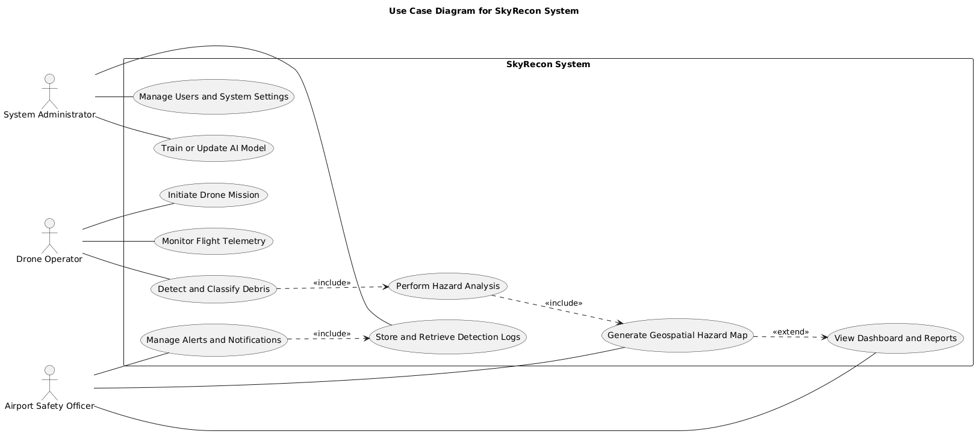

The diagram outlines functional interactions between external actors and the SkyRecon system, showing how drone operators trigger missions, AI modules process detection feeds, and airport officers respond to generated alerts.

2.3 Mock-Up Based Functional Requirements

Mockup M1 – Login Page

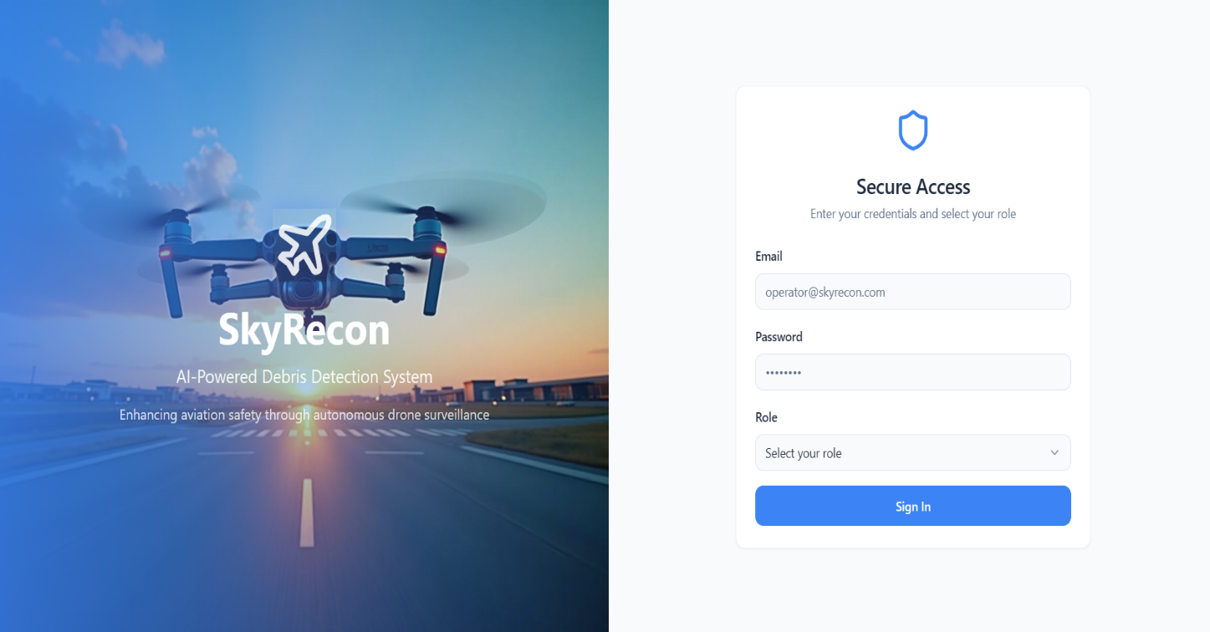
Figure 1
Description:
Split-layout login screen with branding “SkyRecon: AI-Powered Debris Detection System.”
Left pane: promotional image and tagline “Enhancing aviation safety through autonomous drone surveillance.”
Right pane: secure access form requesting Email, Password, and Role selection with a Sign In button.
Feature (Derived from UI) | Functional Requirement (FR-ID : Statement) | Business Rule
User Authentication (M1) | FR1.1: The system shall authenticate users via a secure login using email, password, and role selection. | Only verified @skyrecon.com email addresses are permitted.
Role Selection (M1) | FR1.2: The system shall provide a dropdown for selecting roles (Operator, Analyst, Admin). | Roles must be pre-assigned in the database; mismatches deny access.
Login Form Validation (M1) | FR1.3: The system shall validate input fields for email format and password strength on submission. | Passwords require ≥ 8 characters, 1 uppercase, 1 digit, 1 special symbol.
Promotional Display (M1) | FR1.4: The system shall display branding and tagline without requiring authentication. | Promotional assets must load from static storage and contain no sensitive data.

Mockup M2 – Main Dashboard

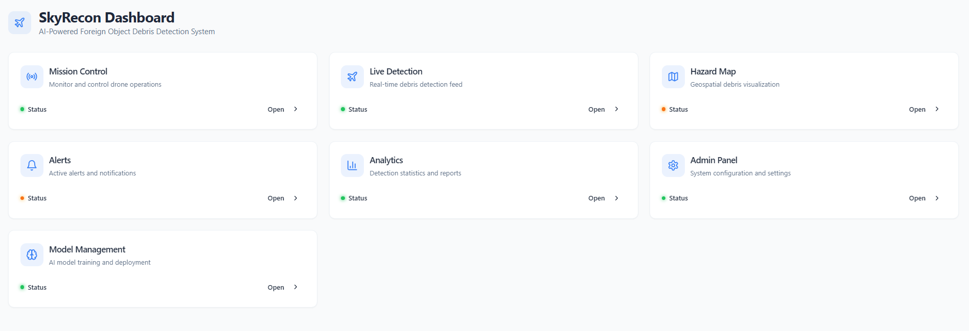
Figure 2
Description:
Central dashboard titled “SkyRecon Dashboard: AI-Powered Foreign Object Debris Detection System.”
Tiles: Mission Control, Live Detection Feed, Hazard Map, Alerts, Analytics, Admin Panel, and Model Management.
Feature (Derived from UI) | Functional Requirement (FR-ID : Statement) | Business Rule
Dashboard Overview (M2) | FR2.1: Display a dashboard with tiles for key modules. | Tile visibility is role-restricted (Operators cannot access Model Management).
Status Indicators (M2) | FR2.2: Show real-time module status (green / orange / red). | Statuses refresh every 10 seconds via backend polling.
Navigation Tiles (M2) | FR2.3: Enable one-click navigation from dashboard tiles. | Navigation actions are logged for audit trails.
Module Accessibility (M2) | FR2.4: Enforce role-based access control on dashboard tiles. | Admins see all tiles; Analysts get read-only views.

Mockup M3 – Alerts and Notifications 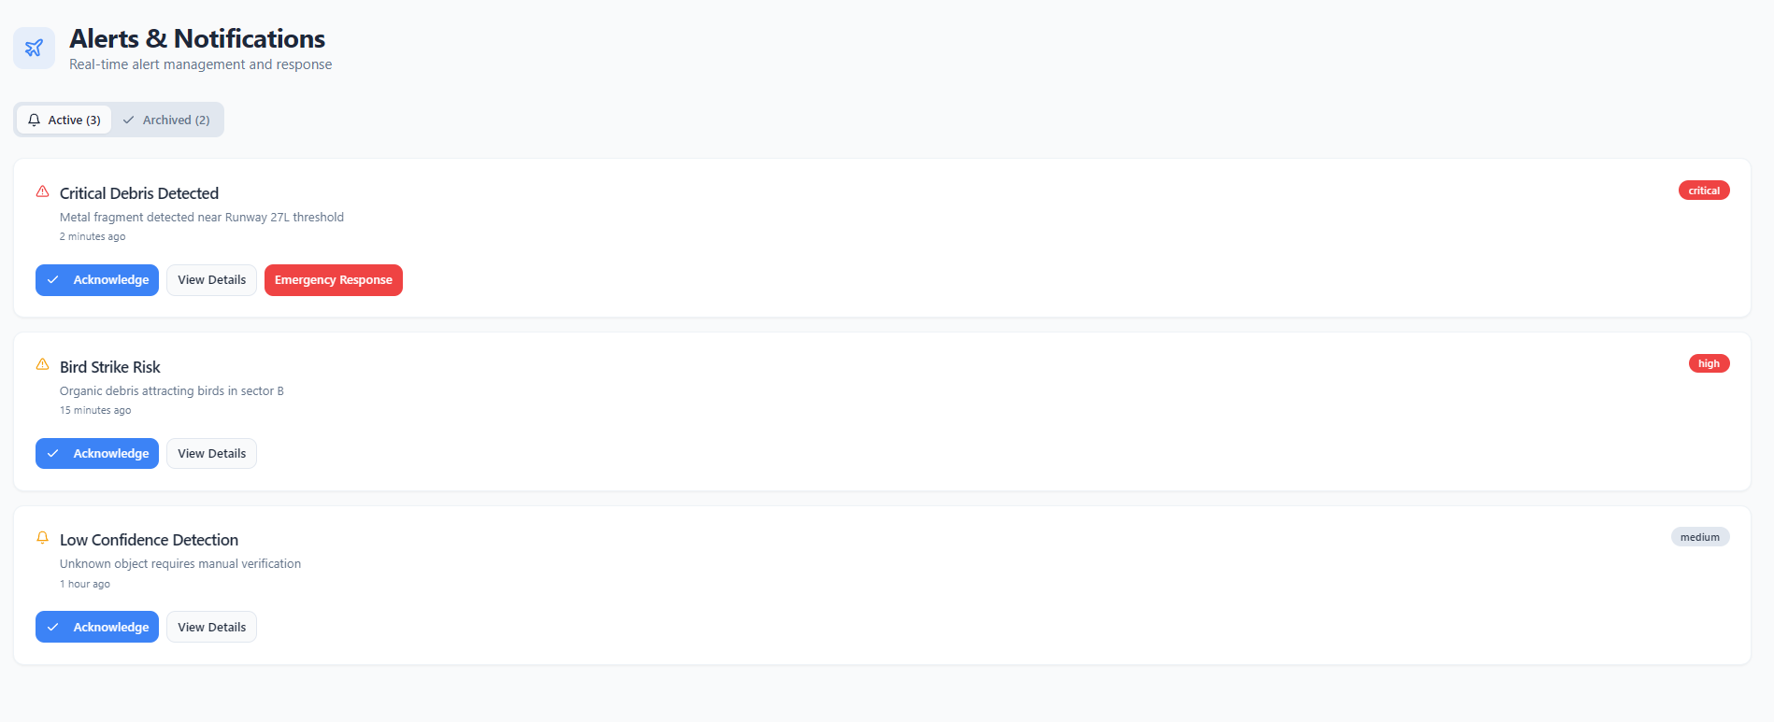
Figure 3
Description:
“Alerts & Notifications” page with Active and Archived tabs showing debris, bird-strike, and risk alerts.
Feature (Derived from UI) | Functional Requirement (FR-ID : Statement) | Business Rule
Alert Tabs (M3) | FR3.1: Provide tabs for Active and Archived alerts with counts. | Archived alerts move after acknowledgment; retention = 90 days.
Alert Details (M3) | FR3.2: Display severity, description, timestamp, and action buttons. | Critical alerts (red) cannot be archived without emergency action.
Action Buttons (M3) | FR3.3: Allow acknowledgment or emergency response. | Emergency responses notify all online admins by email.
Bird Strike Risk (M3) | FR3.4: Generate alerts for organic debris attracting birds. | Such alerts require manual verification within 15 minutes.

Mockup M4 – Mission Control

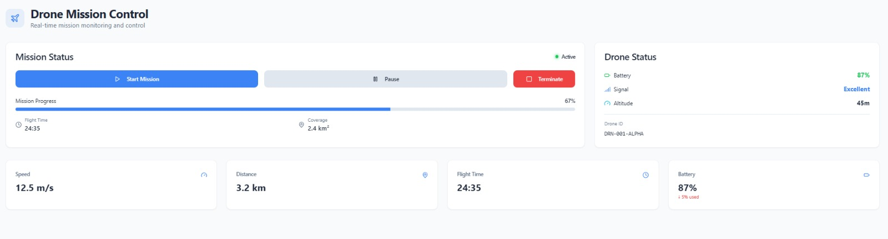
Figure 4
Description:
“Drone Mission Control” screen displaying mission status, progress (%), coverage area, telemetry, and drone ID.
Feature (Derived from UI) | Functional Requirement (FR-ID : Statement) | Business Rule
Mission Status Controls (M4) | FR4.1: Provide Start, Pause, and Terminate buttons. | Mission start allowed only if battery > 20% and signal = Excellent.
Telemetry Metrics (M4) | FR4.2: Display speed, distance, battery, altitude in real time. | Refresh every 5 s; battery < 30% triggers auto-pause.
Progress Bar (M4) | FR4.3: Show mission progress % with coverage area. | Calculated based on pre-defined flight paths.
Drone Identification (M4) | FR4.4: Display Drone ID and status during mission. | One drone per mission; multi-missions require admin approval.

Mockup M5 – Live Detection Feed

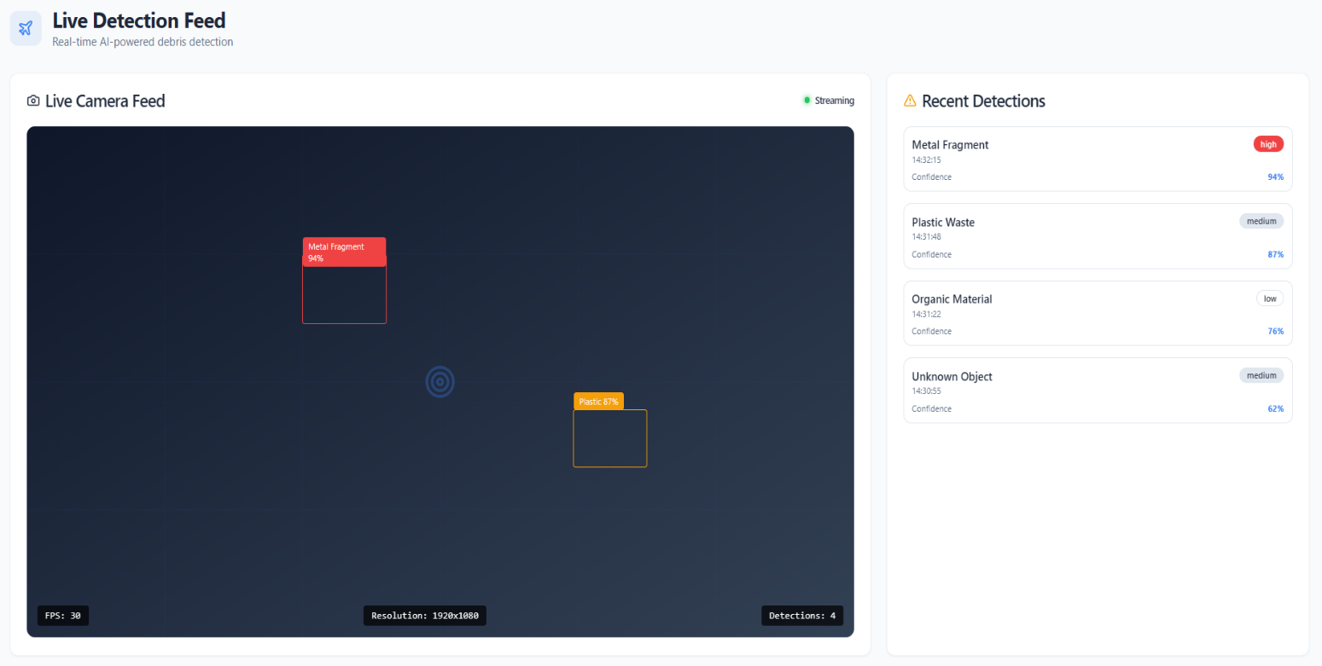
Figure 5
Description:
“Live Detection Feed” page showing video stream with bounding boxes and sidebar for recent detections.
Feature (Derived from UI) | Functional Requirement (FR-ID : Statement) | Business Rule
Live Video Feed (M5) | FR5.1: Stream drone camera feed with AI overlays. | Maintain ≥ 30 FPS; disconnections trigger alerts.
Detection Overlays (M5) | FR5.2: Label detections with type and confidence score. | Confidence < 70% requires manual review.
Recent Detections Sidebar (M5) | FR5.3: List recent detections with timestamps and severity. | Show latest 10 entries per session.
Streaming Status (M5) | FR5.4: Indicate stream status and detection count. | Non-streaming state prompts reconnection option.

Mockup M6 – Hazard Map Dashboard

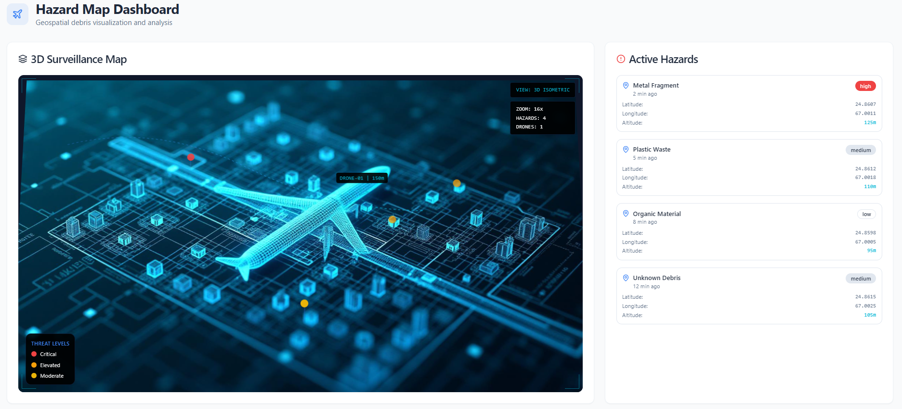
Figure 6
Description:
“Hazard Map Dashboard” with 3D map visualization, threat levels legend, and sidebar of active hazards.
Feature (Derived from UI) | Functional Requirement (FR-ID : Statement) | Business Rule
3D Surveillance Map (M6) | FR6.1: Render 3D interactive map with drone and hazard positions. | Map logs user interactions (zoom, pan).
Hazard Markers (M6) | FR6.2: Display color-coded markers by threat level. | Auto-update every 10 seconds.
Active Hazards Sidebar (M6) | FR6.3: List hazards with latitude, longitude, altitude. | Sorted by severity (desc); click = zoom to location.
Threat Levels Legend (M6) | FR6.4: Provide legend for critical/elevated levels. | Threat levels configurable by admins.

Mockup M7 – Analytics and Reports

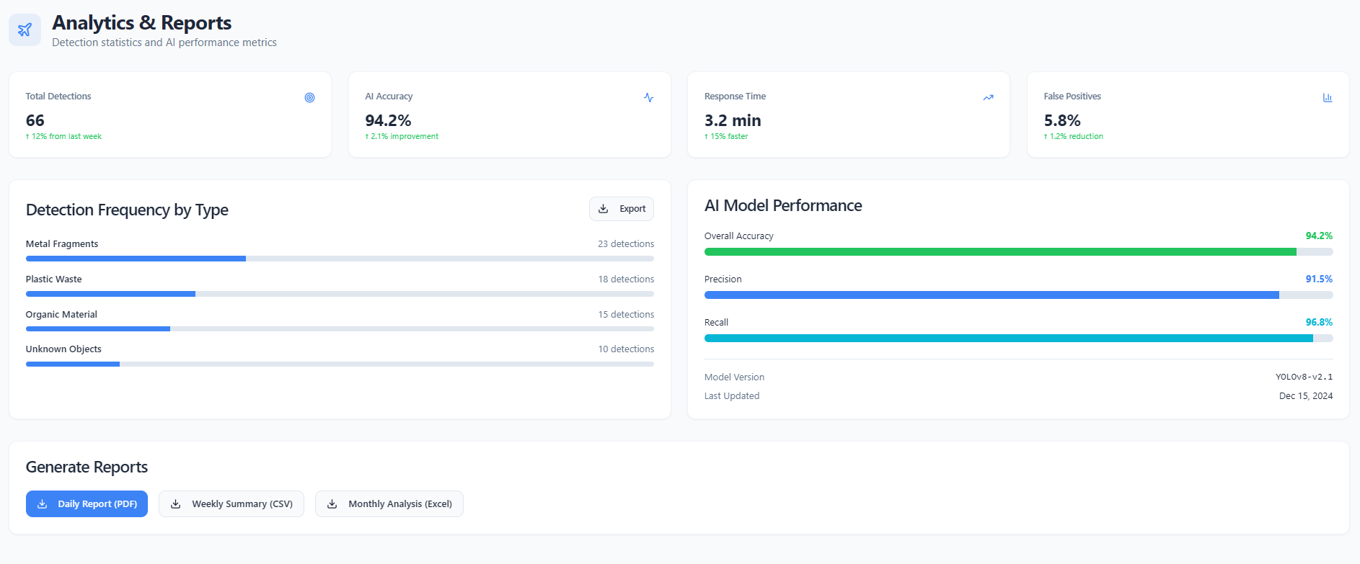
Figure 7
Description:
“Analytics & Reports” page with metrics cards, charts, and report export options.
Feature (Derived from UI) | Functional Requirement (FR-ID : Statement) | Business Rule
Performance Metrics Cards (M7) | FR7.1: Display cards for detections, accuracy, response time, false positives. | Metrics calculated weekly; improvements highlighted in green.
Detection Frequency Chart (M7) | FR7.2: Generate bar charts for detection frequency by type. | Filterable by date range ≤ 1 year.
Model Performance Chart (M7) | FR7.3: Display accuracy, precision, recall progress bars. | Threshold < 90% flags warning.
Report Generation (M7) | FR7.4: Enable report export in PDF, CSV, XLSX. | Reports watermarked with generation date.

Mockup M8 – Model Management

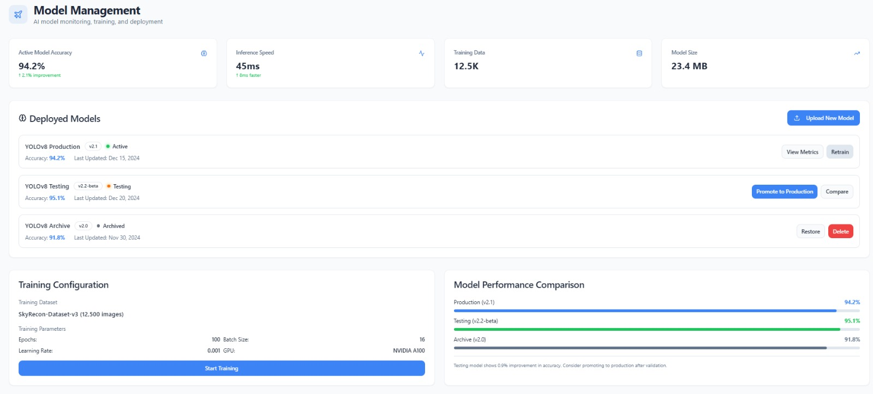
Figure 8
Description:
“Model Management” dashboard displaying active model stats, training configuration, and comparison graphs.
Feature (Derived from UI) | Functional Requirement (FR-ID : Statement) | Business Rule
Model Metrics Display (M8) | FR8.1: Show active model accuracy, speed, size. | Values below benchmarks trigger alerts.
Deployed Models List (M8) | FR8.2: List models with version, status, actions (Promote, Retrain, Archive). | Only admins can promote models to production.
Training Configuration (M8) | FR8.3: Allow setting dataset, batch size, epochs, learning rate, GPU. | Training requires ≥ 1,000 images; default GPU = NVIDIA A100.
Performance Comparison (M8) | FR8.4: Display comparison bars for last 5 model versions. | Historical accuracy averaged for trend tracking.

Mockup M9 – Admin Configuration

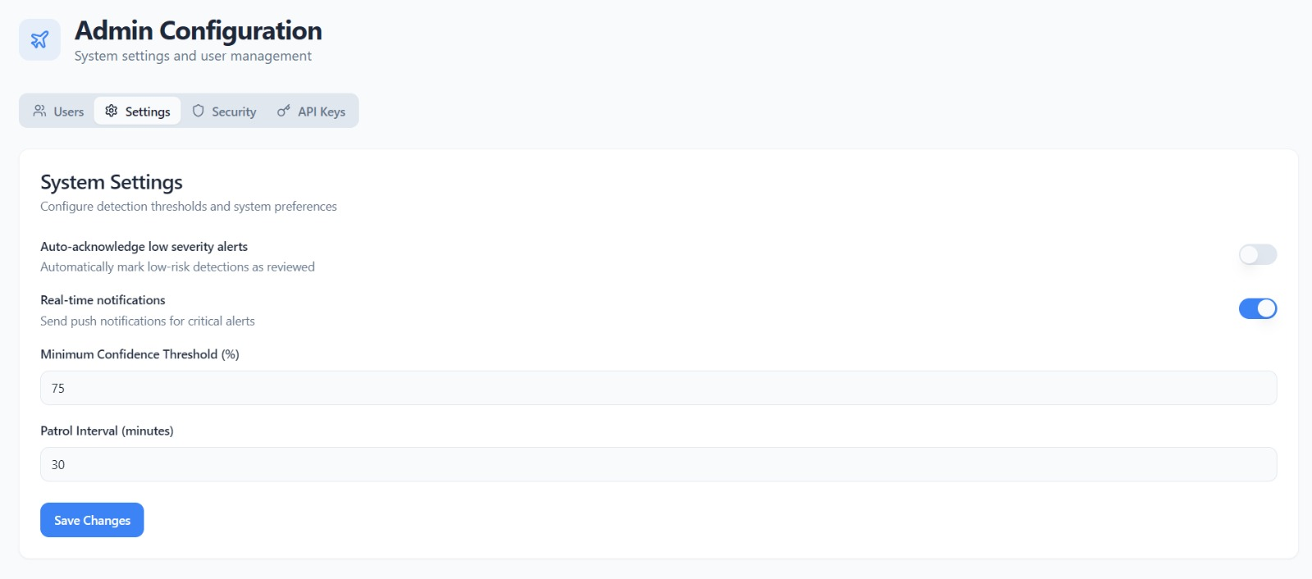
Figure 9
Description:
“Admin Configuration” page for user management, system settings, security, and API key control.
Feature (Derived from UI) | Functional Requirement (FR-ID : Statement) | Business Rule
Configuration Tabs (M9) | FR9.1: Provide tabs for Users, Settings, Security, API Keys. | Tabs are admin-only; unauthorized access logged.
User Management List (M9) | FR9.2: Display user details (name, email, role) with Edit / Remove. | Emails must use @skyrecon.com; removals require confirmation.
Add New User (M9) | FR9.3: Enable adding users with role assignment form. | New users receive temporary passwords via email.
Role-Based Controls (M9) | FR9.4: Allow role and detail modifications with audit logs. | Changes notify affected users automatically.

2.3.1 Backup Process Requirements
This section outlines the backend processes responsible for ensuring data reliability, integrity, and recovery within the SkyRecon system.
Since SkyRecon involves critical aviation safety operations, the backup and recovery pipeline is designed to guarantee uninterrupted functionality, even during unexpected outages, network failures, or system maintenance.

1. Purpose
The purpose of the SkyRecon Backup Process is to:
- Prevent data loss from mission logs, AI detections, and hazard analytics.
- Ensure high availability of telemetry, video feeds, and model performance records.
- Enable fast disaster recovery and continuity of drone operations and dashboards.

2. Scope
The backup process applies to:
- Mission logs, detection metadata, and hazard reports.
- User accounts, roles, and access control records.
- Trained model weights, configuration files, and performance history.
- System configuration, API credentials, and audit logs.

3. Backup Process Overview
SkyRecon’s backend implements a hybrid backup mechanism, combining real-time cloud sync with scheduled local snapshots.
Backup Type | Frequency | Storage Medium | Scope | Retention Policy
Real-Time Sync | Continuous | Cloud Database (PostgreSQL) | Mission logs, detections, user actions | Persistent
Incremental Backup | Every 6 hours | Local Encrypted Disk | New or modified data since last backup | 7 days
Full Database Snapshot | Once daily (23:00 PKT) | Cloud Storage (S3 Bucket / Azure Blob) | Entire operational database | 30 days
Model Checkpoint Backup | After each training cycle | Dedicated ML Storage | Model weights, configs, validation reports | Latest 5 versions
Log Archive | Weekly | Cold Storage | System and alert logs | 3 months

4. Event–Response Mapping Table
Event | System State | Response
1. User Authentication & Security (M1, M9)
User submits login credentials | User session not active | Validate credentials via backend, check role in DB, generate JWT session token
Invalid credentials entered | Authentication failed | Display error, increment failed attempt count
Multiple failed login attempts | Failed attempt threshold reached | Lock account for 15 minutes, notify admin
Password reset requested | Registered email exists | Generate reset token, email reset link to user
Session expires | User inactive for 20 minutes | Invalidate token and require re-authentication
Unauthorized API key usage detected | Token mismatch | Log attempt, revoke key, alert admin via email
2. Dashboard & Module Access (M2)
User logs in successfully | Valid session token | Load personalized dashboard tiles per user role
User selects restricted tile | Access control triggered | Deny access, log attempt, show “Access Denied” message
Dashboard refresh triggered | Session active | Fetch updated module statuses from backend every 10 seconds
Admin views audit logs | Audit table available | Retrieve and display latest user actions with timestamps
3. Drone Mission Control (M4)
Operator starts mission | Battery > 20% & signal excellent | Initialize mission state, start telemetry and video stream
Pause command issued | Active mission | Halt drone movement, maintain hover, preserve progress data
Terminate command issued | Mission in progress | Execute return-to-home routine, store mission log
Telemetry update received | Drone connected | Update metrics (speed, altitude, battery, distance) in DB
Battery < 20% detected | Critical state | Trigger auto-return, send low-battery alert
4. Live Detection & AI Inference (M5)
New video frame received | Stream active | Process frame via YOLOv8 model for debris detection
Detection confidence ≥ 70% | Valid detection | Draw bounding boxes, tag debris type, log event
Confidence < 70% | Low-confidence output | Flag detection for manual analyst review
Stream disconnected | Signal lost | Pause inference, display “Reconnecting” notice, retry stream
Stream restored | Connection re-established | Resume inference and continue logging
5. Hazard Mapping & Analysis (M6)
New detection logged | Valid debris coordinates | Generate hazard marker on 3D map with severity color
Duplicate detection nearby | Same coordinates within 3 meters | Merge detection entries, increment frequency count
High-risk debris detected | Hazard ≥ threshold | Send alert to dashboard and email to admin group
User interacts with map | Session active | Log zoom/pan actions for analytics
Map update interval reached | Scheduled refresh | Fetch latest hazard data and re-render layer
6. Alerts & Notifications (M3)
New alert generated | Backend receives detection event | Classify alert (critical/elevated/low), update Active tab
Alert acknowledged | User action received | Move to Archived tab, record acknowledgment time
Emergency action triggered | Critical alert active | Notify all admins, store emergency response in audit log
Bird strike risk alert created | Organic debris detected | Send high-priority alert for manual verification
Alert expiry reached | Retention > 90 days | Auto-archive expired alerts
7. Analytics & Reporting (M7)
User opens analytics page | Valid session | Retrieve metrics (detections, accuracy, latency, false positives)
Date range filter applied | Query parameters updated | Refresh charts and recalculate summaries
Report export requested | Data available | Generate PDF/CSV/XLSX and apply watermark
Model accuracy < 90% | Threshold violated | Flag model as “Underperforming” and notify admin
Weekly summary trigger | End of week | Generate system performance summary and email report
8. Model Management (M8)
Admin adds new model | New training config received | Validate dataset, initiate model training on GPU
Model training completes | Valid performance metrics | Store accuracy, recall, and precision; mark as ready
Model promoted to production | Admin confirmation | Replace current inference model and log version ID
Model underperforms in field | Accuracy < benchmark | Revert to previous stable model
Comparison requested | Historical records exist | Generate performance graph for last 5 versions
9. Admin & Configuration Management (M9)
Admin adds user | Valid form data | Create user entry, assign temporary password, send email
Admin edits user role | User exists in DB | Update role and log change in audit history
API key regenerated | Valid admin action | Invalidate old key, issue new token, update database
System setting modified | Configuration updated | Persist change in config file and log timestamp
Unauthorized access attempt | Role mismatch | Deny action, record IP and user ID in security logs
10. System Maintenance & Safety
Scheduled maintenance started | End-of-day or off-peak | Notify users, disable new sessions, backup database
Data backup triggered | Schedule reached | Generate and encrypt full database snapshot
UAV enters restricted airspace | Violation detected | Trigger immediate return-home protocol
Strong wind or rain detected | Hazardous weather | Pause mission, land drone safely, and log weather data
Server overload detected | CPU > 90% | Throttle non-critical processes or scale instance
Log cleanup routine triggered | End-of-day | Archive logs older than 30 days into cold storage

5. Backup Validation and Security
- Integrity Verification: Every backup undergoes checksum validation to ensure completeness and authenticity.
- Encryption: All backup archives use AES-256 encryption before storage.
- Access Control: Only system administrators with valid API keys can trigger or restore backups.
- Redundancy: Dual copies of each backup are stored in separate cloud regions to ensure disaster resilience.
- Automated Alerts: Failed or delayed backups trigger automated email and dashboard notifications.

6. Recovery Policy
- Partial Recovery: Individual datasets (e.g., logs, detections, analytics) can be restored without full rollback.
- Full Recovery: System-wide restoration available through admin interface in critical failure scenarios.
- Recovery Time Objective (RTO): ≤ 2 hours.
- Recovery Point Objective (RPO): ≤ 30 minutes of data loss in worst-case conditions.

2.4 Non-Functional Requirements
Non-functional requirements define the quality attributes that ensure the SkyRecon system operates efficiently, reliably, securely, and intuitively across all modules, including drone communication, AI inference, dashboard analytics, and system maintenance.

2.4.1 Reliability
- REL-1: The system shall achieve a Mean Time Between Failures (MTBF) of at least 500 operational hours under standard mission load.
- REL-2: In the event of a network loss, the system shall automatically switch to offline logging mode to preserve mission telemetry and detection data.
- REL-3: The system shall resume mission continuity within 5 seconds after reconnection without manual intervention.
- REL-4: Data consistency between the local drone cache and the central cloud database shall be maintained with 99.9% synchronization accuracy.
- REL-5: The backend services shall ensure 99.5% uptime per month, excluding scheduled maintenance.
- REL-6: Any process or service failure shall trigger an automated restart routine and log the incident for diagnostic review.

2.4.2 Usability
- USE-1: The web dashboard shall provide a clear, responsive layout featuring interactive maps, filters, and color-coded alerts for intuitive navigation.
- USE-2: Drone operators shall be able to start, pause, or stop missions with no more than two clicks on the Mission Control interface.
- USE-3: The system interface shall comply with WCAG 2.1 accessibility standards, ensuring compatibility with assistive technologies.
- USE-4: All dashboards and pages shall load within 3 seconds on a 20 Mbps connection.
- USE-5: Tooltips and context-sensitive help icons shall be provided for all major controls to enhance operator learning and reduce training time.
- USE-6: The interface shall maintain full usability and readability on devices with resolutions ≥1280×720 (desktop/tablet) and support touch-based input controls.

2.4.3 Performance
- PER-1: Object detection inference shall complete within 1.5 seconds per video frame on standard GPU hardware.
- PER-2: The dashboard shall refresh telemetry and detection data every 1 second during live drone missions.
- PER-3: The backend shall handle simultaneous data streams from up to five drones while maintaining ≤80% CPU utilization and ≤70% memory usage.
- PER-4: The hazard heatmap and analytics visualizations shall update in under 2 seconds after each backend refresh.
- PER-5: REST API endpoints shall have an average response time of ≤500 ms under normal operating conditions.
- PER-6: The system shall recover from temporary database downtime and restore operational state within 60 seconds of service restoration.

2.4.4 Security
- SEC-1: All communications between drones, cloud servers, and dashboards shall use TLS 1.3 encryption to ensure data confidentiality.
- SEC-2: Authentication shall comply with OAuth 2.0 standards for both API endpoints and user dashboard access.
- SEC-3: System access shall be role-based, enforcing strict permissions for Operator, Analyst, and Admin roles.
- SEC-4: All failed login attempts shall be logged, and administrators shall receive automated notifications for accounts exceeding three consecutive failures.
- SEC-5: All sensitive credentials, API keys, and tokens shall be stored using AES-256 encryption and rotated every 90 days.
- SEC-6: The system shall perform periodic security audits and vulnerability scans every 30 days, maintaining a compliance log of detected and resolved issues.

2.5 External Interface Requirements
This section specifies the logical interfaces between SkyRecon and its external entities, including users, software components, hardware devices, and communication protocols.

2.5.1 User Interface Requirements
- The user interface follows React.js standards with Leaflet.js map integration.
- Dashboard screens include: Login (M1), Dashboard (M2), Mission Control (M3), Map View (M4), Alerts (M5), and Reports (M6).
- Font and color scheme follow a minimal, high-contrast design for readability.
- Standard navigation links include: Home, Mission Control, Analytics, Alerts, Reports.
- Pop-up messages and toast notifications display operational feedback (e.g., “Mission Started,” “Debris Detected”).
- Accessibility features include both mouse and keyboard navigation support.

2.5.2 Software Interfaces
ID | Software Interface | Requirement Description
SI-1 | Cloud AI Backend (Flask / FastAPI) | Handles YOLOv8 inference and RL navigation orchestration.
SI-2 | PostgreSQL with PostGIS | Stores telemetry, debris detections, and spatial map data.
SI-3 | MQTT / WebSocket Broker | Manages low-latency data exchange between drone and cloud.
SI-4 | React.js Web Dashboard | Displays detections, maps, and analytics to authorized users.

2.5.3 Hardware Interfaces
ID | Hardware Interface | Description
HI-1 | Drone Platform | Equipped with 1080p/30fps camera, GPS, IMU, and Wi-Fi/4G transmitter.
HI-2 | Ground Control Unit | Relays telemetry and video streams between drone and cloud server.
HI-3 | LiDAR / Ultrasonic Sensors (Optional) | Enhances obstacle detection and altitude precision.

2.5.4 Communication Interfaces
ID | Communication Interface | Requirement Description
CI-1 | MQTT Protocol | Enables bidirectional telemetry transfer between drone and cloud.
CI-2 | HTTPS Protocol | Ensures secure dashboard access and encrypted data transfer.
CI-3 | OAuth 2.0 Authentication | Provides secure API-based communication for backend services.

2.6 References
[1] I. Sommerville, Software Engineering, 10th ed. Boston, MA: Pearson, 2015.
[2] A. M. Davis, “The art of requirements triage,” Computer, vol. 36, no. 3, pp. 42–49, 2003.
[3] J. Gubbi, R. Buyya, S. Marusic, and M. Palaniswami, “Internet of Things (IoT): A vision, architectural elements, and future directions,” Future Generation Computer Systems, vol. 29, no. 7, pp. 1645–1660, 2013.
[4] M. T. Rashid, T. Hasan, and M. R. Khan, “Real-time object detection on UAV imagery using deep learning,” IEEE Access, vol. 8, pp. 181698–181709, 2020.
[5] H. Kopetz, Real-Time Systems: Design Principles for Distributed Embedded Applications, 2nd ed. New York, NY: Springer, 2011.
[6] S. Ren, K. He, R. Girshick, and J. Sun, “Faster R-CNN: Towards real-time object detection with region proposal networks,” IEEE Transactions on Pattern Analysis and Machine Intelligence, vol. 39, no. 6, pp. 1137–1149, 2017.
[7] A. Krizhevsky, I. Sutskever, and G. Hinton, “ImageNet classification with deep convolutional neural networks,” in Proc. Advances in Neural Information Processing Systems (NIPS), 2012, pp. 1097–1105.

Plagiarism Report
